Layout

# 大綱

版面的配置 可以藉由 table 達成，或是block-level 標籤達成。

HTML標籤在版面上的顯示，可以分成block-level, inline-level，前者會自動斷行，後者不會。但是利用css 可以進一步控制斷行與否，參考第2節，配合css。

# 版面

## HTML Layout - Using Tables

The simplest and most popular way of creating layouts is using HTML <table> tag. These tables are arranged in columns and rows, so you can utilize these rows and columns in whatever way you like.

##### Example

For example, the following HTML layout example is achieved using a table with 3 rows and 2 columns but the header and footer column spans both columns using the colspan attribute −

<!DOCTYPE html>

<html>

<head>

<title>HTML Layout using Tables</title>

</head>

<body>

<table width = "100%" border = "0">

<tr>

<td colspan = "2" bgcolor = "#b5dcb3">

<h1>This is Web Page Main title</h1>

</td>

</tr>

<tr valign = "top">

<td bgcolor = "#aaa" width = "50">

<b>Main Menu</b><br />

HTML<br />

PHP<br />

PERL...

</td>

<td bgcolor = "#eee" width = "100" height = "200">

Technical and Managerial Tutorials

</td>

</tr>

<tr>

<td colspan = "2" bgcolor = "#b5dcb3">

<center>

Copyright © 2007 Tutorialspoint.com

</center>

</td>

</tr>

</table>

</body>

</html>

This will produce the following result −

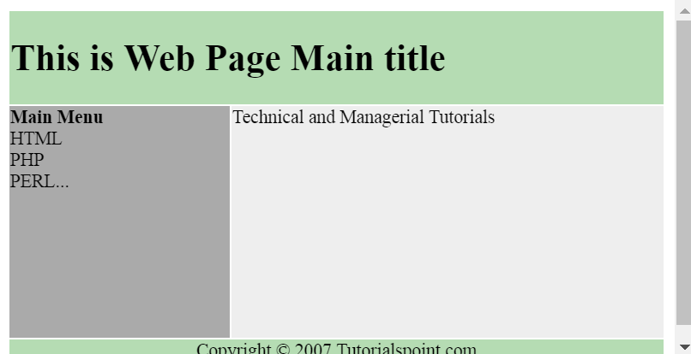

## Multiple Columns Layout - Using Tables

You can design your webpage to put your web content in multiple pages. You can keep your content in middle column and you can use left column to use menu and right column can be used to put advertisement or some other stuff. This layout will be very similar to what we have at our website tutorialspoint.com.

##### Example

Here is an example to create three column layout −

<!DOCTYPE html>

<html>

<head>

<title>Three Column HTML Layout</title>

</head>

<body>

<table width = "100%" border = "0">

<tr valign = "top">

<td bgcolor = "#aaa" width = "20%">

<b>Main Menu</b><br />

HTML<br />

PHP<br />

PERL...

</td>

<td bgcolor = "#b5dcb3" height = "200" width = "60%">

Technical and Managerial Tutorials

</td>

<td bgcolor = "#aaa" width = "20%">

<b>Right Menu</b><br />

HTML<br />

PHP<br />

PERL...

</td>

</tr>

<table>

</body>

</html>

This will produce the following result −

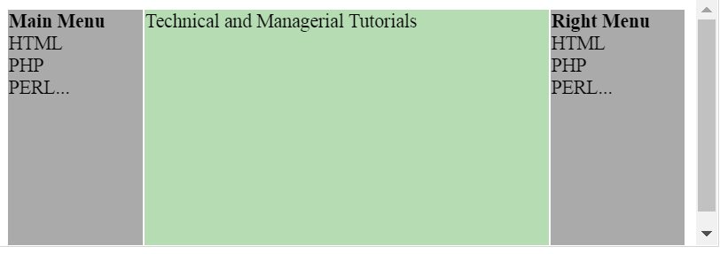

## HTML Layouts - Using DIV, SPAN

The <div> element is a block level element used for grouping HTML elements. While the <div> tag is a block-level element, the HTML <span> element is used for grouping elements at an inline level.

Although we can achieve pretty nice layouts with HTML tables, but tables weren't really designed as a layout tool. Tables are more suited to presenting tabular data.

**Note** − This example makes use of Cascading Style Sheet (CSS), so before understanding this example you need to have a better understanding on how CSS works.

##### Example

Here we will try to achieve same result using <div> tag along with CSS, whatever you have achieved using <table> tag in previous example.

<!DOCTYPE html>

<html>

<head>

<title>HTML Layouts using DIV, SPAN</title>

</head>

<body>

<div style = "width:100%">

<div style = "background-color:#b5dcb3; width:100%">

<h1>This is Web Page Main title</h1>

</div>

<div style = "background-color:#aaa; height:200px; width:100px; float:left;">

<div><b>Main Menu</b></div>

HTML<br />

PHP<br />

PERL...

</div>

<div style = "background-color:#eee; height:200px; width:350px; float:left;" >

<p>Technical and Managerial Tutorials</p>

</div>

<div style = "background-color:#aaa; height:200px; width:100px; float:right;">

<div><b>Right Menu</b></div>

HTML<br />

PHP<br />

PERL...

</div>

<div style = "background-color:#b5dcb3; clear:both">

<center>

Copyright © 2007 Tutorialspoint.com

</center>

</div>

</div>

</body>

</html>

This will produce the following result −

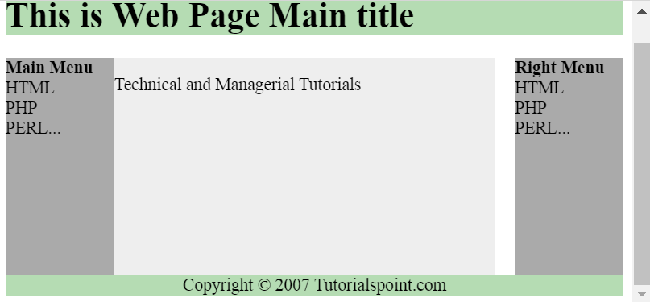

# 配合CSS

<[參考](https://www.w3schools.com/css/css_display_visibility.asp)> 這裡討論了兩個版面常用到的兩個屬性：display, visibility。

## display

CSS相關的屬性中， display 可以用來控制版面或者是用來控制是否參與版面的排版(flow)。

常用值： block， inline， none 。

但是 visibility  雖然也可以控制是否顯示，但是仍然參與版面的排版。

|  |
| --- |
| Block-level Elements 一個block-level 標籤，一定從一個新行開始，一直到整個版面右邊。例如，<div> 就是一個block-level。其他有  <div>  <h1> - <h6>  <p>  <form>  <header>  <footer>  <section> Inline Elements 相對於block-level 的標籤，就是inline ，不必從頭開始，而且也不一定會一直延伸到最右。這種標籤有:  <span>  <a>  <img>  This is an inline <span> element inside a paragraph. |

### 取代預設的display 動作

##### Example: <li>

li {  
    display: inline;  
}

[Try it Yourself »](https://www.w3schools.com/css/tryit.asp?filename=trycss_display_inline_list)

.

##### Example:<span>

span {  
    display: block;  
}

[Try it Yourself »](https://www.w3schools.com/css/tryit.asp?filename=trycss_display_block)

span [參考](http://www.w3school.com.cn/tags/tag_span.asp)

##### Example <a>

a {  
    display: block;  
}

[Try it Yourself »](https://www.w3schools.com/css/tryit.asp?filename=trycss_display_block_a)

## visibility

Hiding an element can be done by setting the display property to none. The element will be hidden, and the page will be displayed as if the element is not there:

##### Example

h1.hidden {  
    display: none;  
}

[Try it Yourself »](https://www.w3schools.com/css/tryit.asp?filename=trycss_display_none)

visibility:hidden; also hides an element.

However, the element will still take up the same space as before. The element will be hidden, but still affect the layout:

##### Example

h1.hidden {  
    visibility: hidden;  
}

[Try it Yourself »](https://www.w3schools.com/css/tryit.asp?filename=trycss_visibility_hidden)

## 範例

display: none; 意思是說此元素不在flow 中，也不顯示。例如範例：

【例】

reset

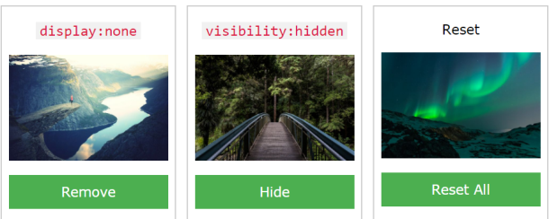

remove

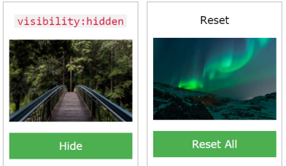

hide

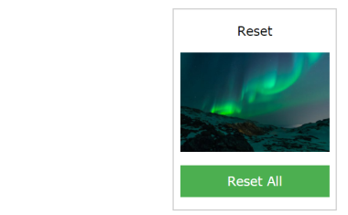

**<script>**

**function** removeElement() {

document.getElementById("imgbox1").style.display **=** "none";

}

**function** changeVisibility() {

document.getElementById("imgbox2").style.visibility **=** "hidden";

}

**function** resetElement() {

document.getElementById("imgbox1").style.display **=** "block";

document.getElementById("imgbox2").style.visibility **=** "visible";

}

**</script>**

在範例(檔案位置:[zip](%5bHTML%5d%2004%20Layout%20練習用.zip))中

display 的值，變換如下：

none <-> block

visibility的值，變換如下(參考後面的章節)：

hidden <-> visible